Police officers help reunite a Syrian family

Last night a Syrian couple, on arriving at the accommodation centre in the Celje Secondary School of Economics on one of the busses from Obrežje with their three-year old daughter, said that their six-year old daughter was missing.

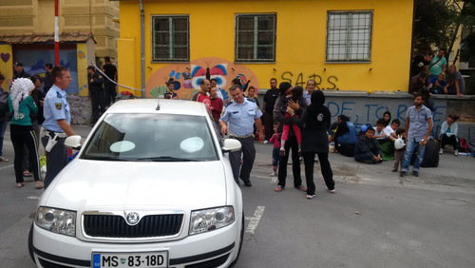

While just before the departure from Obrežje yesterday, the girl's pregnant mother had been taken to hospital for treatment, the six-years old boarded one of the busses taking the foreigners to reception centres across Slovenia. The father and the younger sister stayed in the hospital with the mother, unaware that the girl, who stayed with the group at Obrežje, was going to leave. The parents were devastated to learn that their daughter was missing.

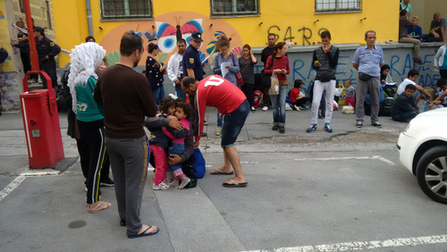

Today the police officers discovered that the missing six-year old Sori was accommodated in the Gornja Radgona accommodation centre together with a relative. Around noon, the girl was taken to Celje by Gornja Radgona police officers to join her parents. They were overwhelmed with joy on meeting each other.

